Elizabeth Babbitt

University of California-Los Angeles

ebabbitt@ucla.edu

Julia Wang

University of California-Los Angeles

jwang03@ucla.edu...

[1]

**Classification on EG Dataset using CNN with LSTM and GRU**

***Abstract* —***This paper shows how our project created several neural networks to decode EEG data. We utilized a Convolution Neural Network (CNN) and a Recurrent Neural Network (RNN) with Long Short Term Memory Network (LSTM). We performed data processing in the form of trimming, maxpooling, averaging, and subsampling. We then compared the time domain neural network to a spectrogram. Our results demonstrate that the CNN model outperforms the CNN + LSTM hybrid model by a slim margin. The algorithm has better gener- alization when training on all subjects (vs. one subject), and the spectrogram CNN model has potential, but was unsuccessful due to limited frequency bands. Simulation shows our best results were the plain/vanilla CNN model (with* 75% *test accuracy) and hybrid CNN + LSTM model (*71% *test accuracy) as the CNN provides a great encoder.*

# **INTRODUCTION**

Our project created several neural networks to decode EEG data. The subjects performed one of four tasks (classes): moving left hand, right hand, feet, and tongue. We utilized data processing in the form of trimming, max- pooling, averaging, and subsampling. We then compared the time domain neural network to a spectrogram. Finally we implemented a Convolution Neural Network (CNN) and a Recurrent Neural Network (RNN) with Long Short Term Memory Network (LSTM). CNN models are excellent for feature extraction, but they are best utilized for static data. CNN models can learn patterns in data using spatial local- ity and spatial invariance [2]. Previous studies have de- coded EEG signals with CNN by creating several “Con- vNets” with different structures with combinations of con- volutions, max pooling, and a last linear classification layer [2]. We based our CNN model on the Convolution-Pool blocks, and we utilized max pooling (which helped enforce

.

# **System Model**

The system used for the analysis and simulation is shown in Figure 1. The Tx and Rx had multiple antenna elements (Nt and Nr of them, respectively) within the system. Each antenna element was polarization-agile with a polarization vector ${\vec{p}}_{Tx,j}$ (or ${\vec{p}}_{Rx,i}$) (with $j ∈ \left\{1, ...,N_{t}\right\} and i ∈ \left\{1,...,N_{r}\right\}$) which could be adjusted based on the channel state information (CSI). It was assumed that the system had perfect CSI at the transmitter (CSIT) and the receiver (CSIR).

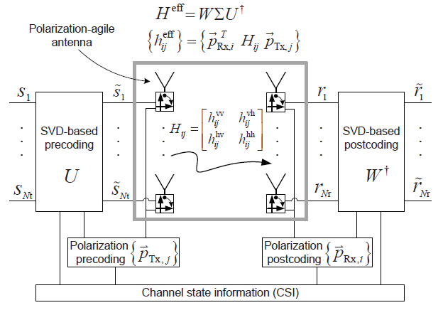

*Fig. 1. Block Diagram MIMO System with Polarization-Agile Antenna*

The effective channel impulse response matrix of the system given in Fig. 1 was expressed as

$H^{eff} =\left[\begin{matrix}{\vec{p}}_{Rx,1}^{T}H_{11}{\vec{p}}_{Tx,1} & {\vec{p}}_{Rx,1}^{T}H_{1Nt}{\vec{p}}_{Tx,Nt} \\ {\vec{p}}_{Rx,Nr}^{T}H_{Nr1}{\vec{p}}_{Tx,1} & {\vec{p}}_{Rx,Nr}^{T}H_{NrNt}{\vec{p}}_{Tx,Nt}\end{matrix}\right]$, (1) where $H_{ij}$ was called the “polarization-basis matrix” expressed as

$H_{ij }= \left[\begin{matrix}h_{ij}^{vv} & h_{ij}^{vh} \\ h_{ij}^{hv} & h_{ij}^{hh}\end{matrix}\right]$, (2)

where $h_{ij}^{xy}$ with $x∈\left\{v,h\right\} and y∈ \left\{v,h\right\}$ is the XY-channel impulse response from the Y-polarization Tx antenna to the X-polarization Rx antenna. Finally, ${\vec{p}}_{Tx,j} and {\vec{p}}_{Rx,i}$, respectively, were called the jth Tx antenna’s Tx-polarization vector and the ith Rx antenna’s Rx-polarization vector, which were defined by

${\vec{p}}_{Tx,j}=\left[\begin{matrix}p_{Tx,j}^{v} \\ p_{Tx,j}^{h}\end{matrix}\right]=\left[\begin{matrix}{\cos{θ}}_{j} \\ {\sin{θ}}_{j}\end{matrix}\right]$, (3)

${\vec{p}}_{Rx,i}=\left[\begin{matrix}p_{Rx,i}^{v} \\ p_{Rx,i}^{h}\end{matrix}\right]=\left[\begin{matrix}{\cos{θ}}_{i} \\ {\sin{θ}}_{i}\end{matrix}\right]$. (4)

$θ_{j}$ and $θ_{i}$ are the Tx- and Rx-polarization angles, respectively.

# Polarization Pre-Post coding at the polarization-agile antenna

## Polarization Precoding and Postcoding with Optimal Tx- and Rx-polarization

With the full CSIT and CSIR, the channel capacity with singular value decomposition (SVD) based pre and postcoding is

$C=\sum_{k=1}^{R_{H^{eff}}}{\log_{2}\left(1+\frac{P_{k}}{σ_{n}^{2}}σ_{k}^{2}\right)}$, (5)

where $R_{H^{eff}}$ is the rank of the matrix $H^{eff}$, and $P_{k}$ is the power allocated to the kth eigenmode. Also, $σ_{k}$ is the singular value of the effective channel impulse response matrix, and $σ_{n}^{2}$ is the noise power. Maximum capacity occurs when $P_{k}$ satisfies the waterfilling conditions

$P_{k}= max \left(0,ε-\frac{σ_{n}^{2}}{σ_{k}^{2}}\right) s.t. P=\sum_{k=1}^{R_{H^{eff}}}{P_{k}}$, (6)

Where the threshold $ε$ is determined by the constraint of the total transmission power P.

Using Jensen’s Inequality, we got

$C≤R_{H^{eff}}\log_{2}\left(1+\frac{1}{R_{H^{eff}}}\sum_{k=1}^{R_{H^{eff}}}{\frac{P_{k}}{σ_{n}^{2}}}σ_{k}^{2}\right)$ (7)

$= R_{H^{eff}} \log_{2}\left(\frac{1}{R_{H^{eff}}} \frac{ε}{σ_{n}^{2}} \sum_{k=1}^{R_{H^{eff}}}{σ_{k}^{2}}\right)$, (8)

In which high signal-to-noise ratio (SNR) was assumed. Following this, $σ_{k}^{2}$ is the eigenvalue of $\left(H^{eff}{\left(H^{eff}\right)}^{†}\right)$, which means,

$\sum_{k=1}^{R_{H^{eff}}}{σ_{k}^{2}}=Tr \left(H^{eff}{\left(H^{eff}\right)}^{†}\right)=\sum_{n,m}{{\left|h_{nm}^{eff}\right|}^{2}}$, (9)

Using the definition of $h^{eff}$ in Fig. 1, we then found

$\sum_{k=1}^{R_{H^{eff}}}{σ_{k}^{2}} = \sum_{j=1}^{N_{t}}{\sum_{i=1}^{N_{r}}{{\vec{p}}_{Tx,j}^{T}}\left(H_{ij}^{†}{\vec{p}}_{Rx,i}{\vec{p}}_{Rx,i}^{T}H_{ij}\right){\vec{p}}_{Tx,j}}$,

$= \sum_{j=1}^{N_{t}}{{\vec{p}}_{Tx,j}^{T}}H_{Tx,j}^{PD}{\vec{p}}_{Tx,j}$, (10)

where

$H_{Tx,j}^{PD} ≜ \sum_{i=1}^{N_{r}}{H_{ij}^{†}{\vec{p}}_{Rx,i}{\vec{p}}_{Rx,i}^{T}H_{ij}}$. (11)

Each Tx antenna is independent from every other Tx antenna, therefore, the best Tx-polarization vector at the jth antenna, ${\vec{p}}_{Tx,j}$, is the one that maximizes ${\vec{p}}_{Tx,j}^{T}H_{Tx,j}^{PD}{\vec{p}}_{Tx,j}$ in (10).

Geometrically, this is an ellipse defined by the equation

${\vec{p}}_{Tx,j}^{T}H_{Tx,j}^{PD}{\vec{p}}_{Tx,j} = c_{j}$, as shown in Fig. 2, where ${\vec{e}}_{1} and {\vec{e}}_{2}$ are the eigenvectors of matrix $H_{Tx,j}^{PD}$, and $λ_{1}^{PD} and λ_{2}^{PD}$ are the corresponding eigenvalues.

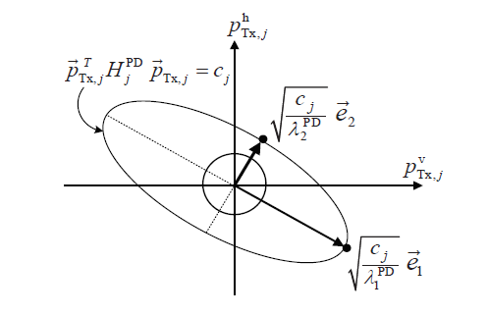

*Fig. 2. Polarization-determinant ellipse and polarization-vector unit circle*

The Tx-polarization vector which maximizes ${\vec{p}}_{Tx,j}^{T}H_{Tx,j}^{PD}{\vec{p}}_{Tx,j}$ while being on the unit circle along with the corresponding Tx-polarization angle are

${\vec{p}}_{Tx,j}^{opt} = arg \max_{{\vec{p}}_{Tx,j}}{{\vec{p}}_{Tx,j}^{T}H_{Tx,j}^{PD}{\vec{p}}_{Tx,j}} = {\vec{e}}_{2}$, (12)

$θ_{j}^{opt} = arctan({\vec{e}}_{2})$. (13)

In a similar fashion, the Rx-polarization vector and corresponding Rx-polarization angle can be found to be

${\vec{p}}_{Rx,i}^{opt} = arg \max_{{\vec{p}}_{Rx,i}}{{\vec{p}}_{Rx,i}^{T}H_{Rx,i}^{PD}{\vec{p}}_{Rx,i}} = {\vec{e}}_{2}$, (14)

$θ_{i}^{opt} = arctan({\vec{e}}_{2})$, (15)

where

$H_{Rx,i}^{PD} ≜ \sum_{j=1}^{N_{t}}{H_{ij}^{†}{\vec{p}}_{Tx,i}{\vec{p}}_{Tx,i}^{T}H_{ij}}$. (16)

## Joint Polarization Pre-post Coding for Polarization Matching

Since the Tx-polarization-determinant matrix depends on the Rx-polarization vectors ${\vec{p}}_{Rx,i}$ and vice versa, it becomes difficult to determine the joint polarization. This paper offered an iterative method of approaching the optimal joint polarization, in which the first iteration is a sequential loop of polarization precoding, and then a loop of polarization postcoding. It works by having ${\vec{p}}_{Tx,j}^{opt,(k-1)}$ be updated on the kth iteration to ${\vec{p}}_{Tx,j}^{opt,(k)}$ based on ${\vec{p}}_{Rx,i}^{opt,(k-1)}$. Then ${\vec{p}}_{Rx,i}^{opt,(k-1)}$ is updated based on the new ${\vec{p}}_{Tx,j}^{opt,(k)}$.

# Numerical Experiments and Results

This section gave the evaluation of the proposed polarization pre-post coding scheme by comparing it to a brute force numerical optimization method under varying conditions. The step width of the brute-force method was 1˚ in Figs. 3 and 4, 5˚ in Figs. 5 and 6, and 10˚ in Figs. 7 and 8.

First, we looked at a 2 x 2 MIMO system with an SNR of 5 dB and 30 dB in Figs. 3 and 4, respectively. There is little difference in channel capacity between the polarization precoding and the numerical result.

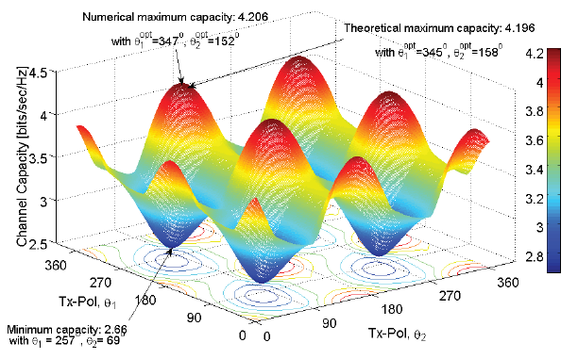

*Fig. 3. Channel Capacity for varying Tx-Polarization; 5 dB SNR*

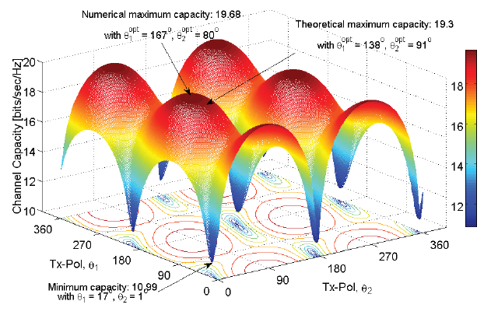

*Fig. 4. Channel Capacity for Varying Tx-Polarization; 30 dB SNR*

Fig. 5 showed the channel capacity for a 2 x 2 MIMO system with the optimal Tx-polarization angles with varying Rx-polarization angles. There is substantial variation of channel capacity when varying Rx-polarization angles when the Tx-polarization angle has been determined using numerical brute-force methods. This shows that the mismatching of Tx- and Rx-polarization has a detrimental effect on the channel capacity.

Fig. 6 showed the optimal Tx- and Rx-polarization vectors for each iteration of joint polarization pre-post coding, using the same 2 x 2 MIMO system. The joint polarization vectors quickliy converge toward the numerical optimum.

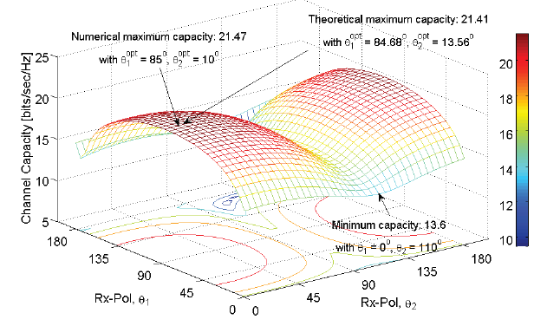

*Fig. 5. Channel Capacity for varying Rx-Polarization with optimal Tx-polarization; 30 dB SNR*

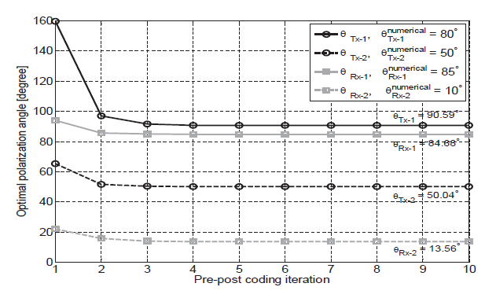

*Fig. 6. Optimal Tx/Rx-polarization angles for the number of iterations;*

*30 dB SNR*

Figs. 7 and 8 showed the cumulative density functions (cdf’s) of the 2 x 2 Polarized MIMO channel capacity along with the cdf’s of the optimal and worst Tx/Rx-polarization obtained by numerical brute-force method at 5 dB SNR and 30 dB SNR, respectively. The joint polarization pre-post coding improved the channel capacity at both 5 dB SNR and 30 dB SNR, meaning there was a higher probability of a greater channel capacity than the brute-force method.

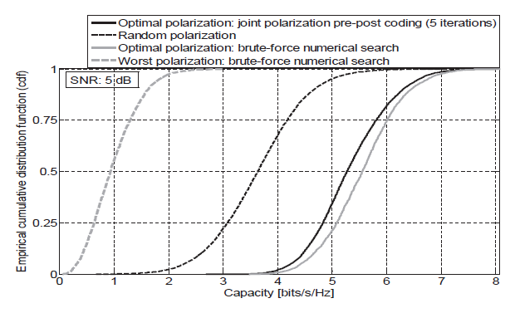

*Fig. 7. cdf’s of Channel Capacity for the Scenarios of Joint Polarization Pre-post Coding with five Iterations, random Tx/Rx-Polarization; Optimal and the worst Tx/Rx-Polarization through Brute-force Numerical search at 5 dB SNR*

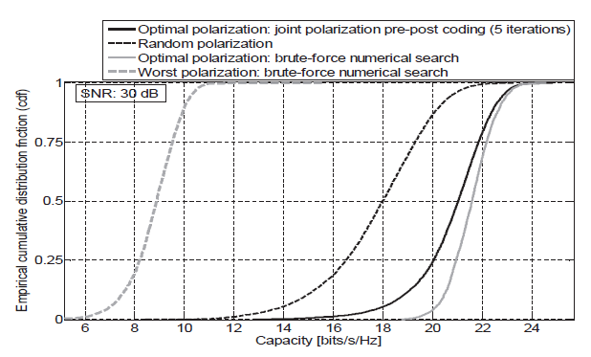

*Fig. 8. cdf’s of Channel Capacity for the Scenarios of Joint Polarization Pre-post Coding with five Iterations, random Tx/Rx-Polarization; Optimal and the worst Tx/Rx-Polarization through Brute-force Numerical search at 30 dB SNR*

Finally, Fig. 9 showed a comparison of varying SNR and varying number of polarization-agile antennas. The joint polarization had an improved channel capacity over the other schemes.

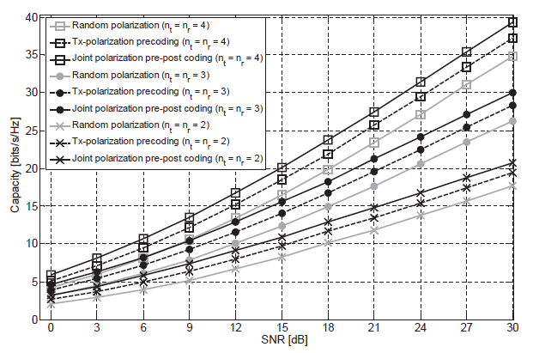

*Fig. 9. Polarized MIMO channel capacity for the Varying SNR in the Scenarios of Random Tx/Rx-polarization, Tx-polarization Precoding, and Joint Polarization Pre-post Coding*

# Conclusion

## The proposed scheme for polarization-agile antennas in polarized MIMO by iteratively updating the polarization angles of the Tx and Rx has been shown to increase the channel capacity of the system by 3 dB to 5 dB. This method has given an alternative scheme that is low-cost with lowenergy consumption to improve the channel capacity of MIMO systems.

**References**

[1]  H. Amin et al. Classification of eeg signals based on pattern recognition approach. *Front. Neurosci.*, 11:1–12, Nov 2017.

[2]  R. Schirrmeister et al. Deep learning with convolutional neu- ral networks for eeg decoding and visualization. *Hum Brain Mapp.*, 14:5391–5420, Nov 2017.

[3]  G. Xu et al. A one-dimensional cnn-lstm model for epilep- tic seizure recognition using eeg signal analysis. *Front. Neu- rosci.*, 38:1–9, Dec 2020.

1.